**How to Focus on What’s Important, Not Just What’s Urgent**

by

* [Alice Boyes](https://hbr.org/search?term=alice%20boyes)

July 03, 2018

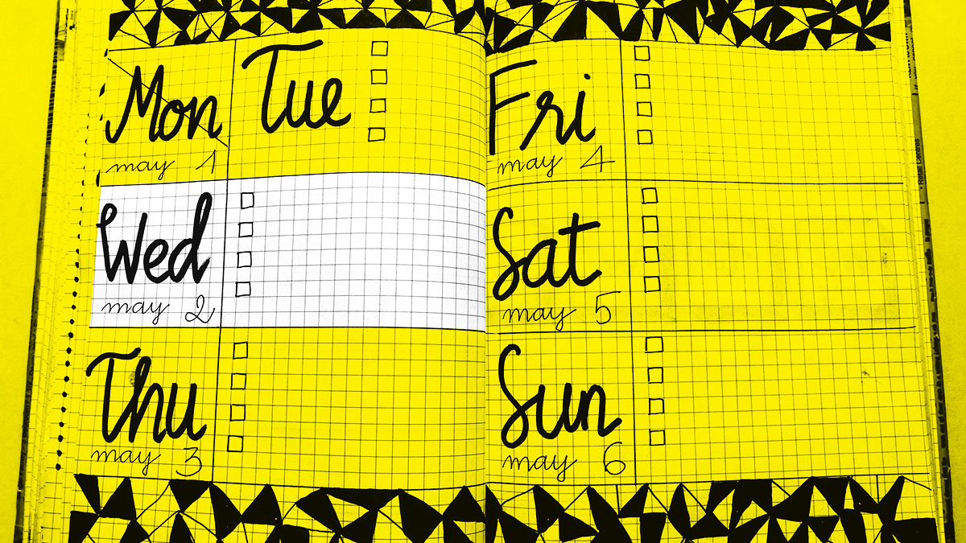

Bich Tran/pexels

Summary.   Research shows that people typically prioritize tasks with the shortest deadlines — even if those tasks aren’t the most important or valuable. In this piece, the author suggests several strategies to help you be more intentional about what you spend your time on:...more

Do you get to the end of the day and feel that you’ve met your most pressing deadlines but haven’t accomplished anything that’s fundamentally important? You’re hardly alone. In a series of studies recently published in the [Journal of Consumer Research](https://academic.oup.com/jcr/advance-article-abstract/doi/10.1093/jcr/ucy008/4847790?redirectedFrom=fulltext), people typically chose to complete tasks that had very short deadlines attached to them, even in situations in which tasks with less pressing deadlines were just as easy and promised a bigger reward.

It’s natural to want to get deadline-driven tasks squared away and off your mental to-do list. A paradox many people face is that our most meaningful tasks are less likely to have deadlines than tasks that are relatively unimportant. Your important priorities might relate to:

* enacting your values (for example, volunteering or spending more time with your children)
* achieving public recognition (getting invited to sit on industry panels or writing a book)
* improving vital skills (upping your knowledge of statistics or learning a new language)
* averting disasters (scheduling an annual checkup at the doctor or creating a crisis management protocol for your business)

If you’re like most people, these priorities slip to the back of your mind while you work on low-importance, time-specific tasks, such as booking a hotel room for a conference, clearing out your email inbox, or writing a monthly newsletter.

So, what can you do? I’ve put together a list of practical strategies and tips, but know that none of these suggestions is going to lead to your making perfect choices. Aiming for perfection [is what causes people to stay stuck](https://hbr.org/2018/04/how-perfectionists-can-get-out-of-their-own-way). Instead, implement strategies that will incrementally move you in the right direction but don’t require much effort.

**Schedule Important Tasks, and Give Yourself Way More Time Than You’ll Need**

[Research](https://www.psych.nyu.edu/gollwitzer/97GollBrand_ImpIntGoalPurs.pdf) shows that scheduling when and where you’ll do something makes it dramatically more likely that the task will get done.

For very important and long-avoided tasks, I like a strategy that I call “clearing the decks,” which means assigning a particular task to be the *only*one I work on for an entire day. I recently used this strategy to get myself to set up a password manager, something I’d been putting off for literally years.

Unfamiliar but important tasks often have a learning curve that makes how much time they’ll take to complete unpredictable. Working on them often feels more clumsy than efficient, which is another subtle factor in why we don’t do them. The “clear the decks” strategy of allowing yourself a full day, even when that seems excessive, can be useful in these cases.

So that you don’t put off important personal care, try having a designated time slot once a week that’s available for you to make a personal appointment during work hours, should this be necessary. This can help ensure you get medical issues investigated early. Most weeks the slot will go unused, but keep it walled off for when the need arises.

**Isolate the Most Impactful Elements of Important Tasks**

Big tasks often require incremental progress. Coming back to the password manager example, my initial goal had been to create new, strong, and unique passwords for all my online accounts, but this wasn’t absolutely necessary. It made most sense to start with my 10 to 20 most valuable accounts.

If you habitually set goals so lofty you end up putting them off, try this: When you consider a goal, also consider a half-size version. Mentally put your original version and the half-size version side by side, and ask yourself which is the better (more realistic) goal. If your task still feels intimidating, shrink it further until it feels doable. You might end up with a goal that’s one-fourth or one-tenth the size of what you initially considered but that’s more achievable — and once you start, you can always keep going.

**Anticipate and Manage Feelings of Anxiety**

Many important tasks involve tolerating thinking about things that could go wrong, which is anxiety-provoking. Examples: making a will, investigating a lump, succession planning for your business, actually reading your insurance policies, or creating that crisis management plan.

Even when tasks don’t involve contemplating catastrophes, those that have the potential for large payoffs in the future commonly involve tolerating anxiety. General examples of important but potentially anxiety-provoking tasks include: developing new friendships, doing something challenging for the first time, asking for what you want, having awkward conversations, facing up to and correcting mistakes, and chipping away at large, multi-month tasks where you need to tolerate fluctuating self-confidence and doubt throughout the project.

Broadly speaking, working on important things typically requires having good skills for tolerating uncomfortable emotions. Here’s a personal example: Reading the work of writers who are better than I am is useful for improving my skills, but it triggers envy and social comparison. Acknowledging and [labeling the specific emotions](http://journals.sagepub.com/doi/abs/10.1177/0963721414550708) that make an experience emotionally challenging is a basic but effective step for reducing those emotions.

You’ll be better able to pursue goals that involve going outside your psychological comfort zone if you have top-notch skills for managing your thoughts and emotions.

**Spend Less Time on Unimportant Tasks**

Unimportant tasks have a nasty tendency of taking up more time than they should. For example, you might sit down to proofread an employee’s report — but before you know it, you’ve spent an hour rewriting the whole thing. In the future, you might decide to limit yourself to making your three most important comments on any piece of work that’s fundamentally acceptable, or give yourself a time limit for how long you’ll spend providing notes.

Having strategies for making quicker decisions can help too. When you’ve got a pressing decision to make, it can be better to make a quick decision than a perfect one that takes more time.

**Prioritize Tasks That Will Reduce Your Number of Urgent but Unimportant Tasks**

In modern life, it’s easy to fall into the trap of being “too busy chasing cows to build a fence.” The sorts of scenarios you most want to avoid are fixing the same problems over and over or giving the same instructions repeatedly. To overcome a pattern of spending all day “chasing cows,” you can outsource, automate, batch small tasks, eliminate tasks, streamline your workflow, or create templates for recurring tasks. Look for situations in which you can make an investment of time once to set up a system that will save you time in the future, such as setting up a recurring order for office supplies rather than ordering items one at a time as you run out.

One specific strategy I cover in [*The Healthy Mind Toolkit*](https://www.amazon.com/Healthy-Mind-Toolkit-Simple-Strategies/dp/0143130706) is retraining the “decision leeches” in your life. Decision leeches are people who defer decisions to you. For example, you might ask someone else to make a decision, but instead of doing it, they email you a list of options for you to look at, putting the responsibility back on you. Instead of automatically answering the person, ask them to make a clear recommendation.

**Pay Attention to What Helps You See (and Track) the Big Picture**

When we’re head-down in the grind, it’s hard to have enough mental space to see the big picture. Pay attention to what naturally helps you do this. Something that helps me is travel, especially taking flights alone. There’s nothing like a literal 10,000-foot view to give me a clearer perspective on my path. Spreadsheets help me see the big picture too. As much as I hate bookkeeping and taxes, doing them helps me pay attention to and optimize my overall situation. Taking more breaks can help stop you going down the rabbit hole of spending a lot of time on unimportant things without realizing that’s what you’re doing.

Another thing that helps keep me focused on my important goals is catching up with colleagues I see every six months or so. Invariably this involves giving each other an update on what we’ve been doing and what we’re trying to get done. Likewise, when it comes to money, there are certain personal finance bloggers I like to read from time to time to help me stay on track.

Tracking your time use can help too, but the downside is that tracking itself takes time and willpower. I use the RescueTime app to effortlessly track how much time I’m spending on different websites (including Gmail). Then I take a quick glance at the report each week.

Whatever helps you see the big picture, don’t skip those things. Also, give yourself time after those activities to figure out how you’re going to translate your insights into specific plans and actions.

If you’re struggling with prioritizing the important over the urgent, don’t be too hard on yourself. The number of deadlines and decisions we face in modern life, juxtaposed with the emotionally (and cognitively) challenging nature of many important tasks, makes this struggle an almost universal one. I’ve written entire books on how to focus on the big picture and stop self-sabotaging, and I still find it difficult. I consider success as taking my own advice at least 50% of the time! This is a reasonable rule of thumb that you might adopt, too.